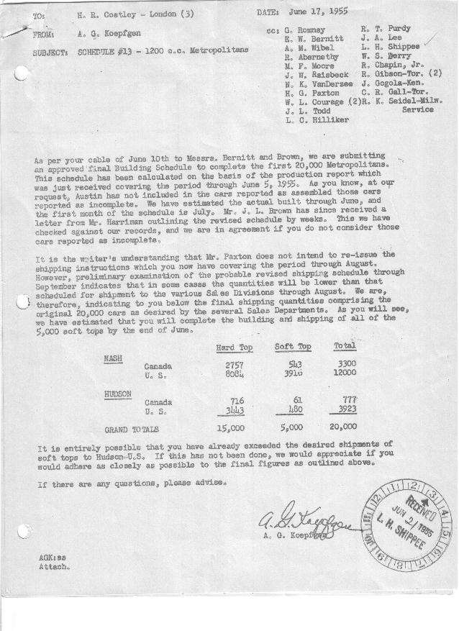

FORM PLAN 68 REV. 2-55-A.M.P APPROVED J. W. Raisbeck & R. T. Purdy(signed) DATE 6-17-55 & 6-20-55

SCHEDULE NO. ______13________ DATE 6- 16 -55 MONTHLY BUILDING SCHEDULE APPROVED W. L Courage (signed)_ DATE_ 6-17-55 ____ REVISION NO. _______ _______ DATE __ PRODUCT APPROVED_E. W. Bernitt (signed) ___________DATE_ 6-20-55 ____
-Final on 1200 c.c. Engine
METROPOLITAN SERIES CARS – AUSTIN MOTORS C. LTD., ENGLAND
DESCRIPTION | BUILT  ◻ACT EST  THRU  JUNE | FIRM BUILDING SCHEDULE  (FABRICATED MATERIAL RELEASE) |  |  |  |  |  |  |  |  |  |  |  |  |  |  | TENTATIVE SCHEDULE  (RAW MATERIAL RELEASED) |  |  | GRAND  TOTAL
DESCRIPTION | BUILT  ◻ACT EST  THRU  JUNE | MONTH JULY 1955  DAYS 16 |  |  | MONTH AUGUST  DAYS 18 |  |  | MONTH SEPTEMBER  DAYS 22 |  |  | MONTH OCTOBER  DAYS 21 |  |  | MONTH NOVEMBER  DAYS 22 |  |  |  |  |  | GRAND  TOTAL
DESCRIPTION | BUILT  ◻ACT EST  THRU  JUNE | DAILY | MONTH | CUM’L  TOTAL | DAILY | MONTH | CUM’L  TOTAL | DAILY | MONTH | CUM’L  TOTAL | DAILY | MONTH | CUM’L  TOTAL | DAILY | MONTH | CUM’L  TOTAL | DAILY | MONTH | TOTAL | GRAND  TOTAL
NASH
Hard-Top | 9733 |  | 339 | 10072 |  | 176 | 10248 |  | 202 | 10450 |  | 192 | 10642 |  | 199 | 10841
Soft-Top | 4459 |  | -0- | 4459 |  | -0- | 4459 |  | -0- | 4459 |  | -0- | 4459 |  | -0- | 4459
Sub-Total | 14192 |  | 339 | 14531 |  | 176 | 14707 |  | 202 | 14909 |  | 192 | 15101 |  | 199 | 15300
Over/(Under) Sched. 12 | 88 |  | (58) | 30 |  | (282) | (252) |  | (139) | (391) |  | 192 | (199) |  | 199 | -0-
HUDSON
Hard-Top | 3708 |  | 141 | 3849 |  | 58 | 3907 |  | 84 | 3991 |  | 81 | 4072 |  | 87 | 4159
Soft-Top | 541 |  | -0- | 541 |  | -0- | 541 |  | -0- | 541 |  | -0- | 541 |  | -0- | 541
Sub-Total | 4249 |  | 141 | 4390 |  | 58 | 4448 |  | 84 | 4532 |  | 81 | 4613 |  | 87 | 4700
Over/(Under) Sched. 12 | 49 |  | (22) | 27 |  | (114) | (87) |  | (81) | (168) |  | 81 | (87) |  | 87 | -0-
GRAND TOTALS
Hard-Top | 13441 |  | 480 | 13921 |  | 234 | 14155 |  | 286 | 14441 |  | 273 | 14714 |  | 286 | 15000
Soft-Top | 5000 |  | -0- | 5000 |  | -0- | 5000 |  | -0- | 5000 |  | -0- | 5000 |  | -0- | 5000
Total | 18441 |  | 480 | 18921 |  | 234 | 19155 |  | 286 | 19441 |  | 273 | 19714 |  | 286 | 20000
Over/(Under) Sched. 12 | 137 |  | (80) | 57 |  | (396) | (339) |  | (220) | (559) |  | 273 | (286) |  | 286 | -0-

